Hyperbola is a very important lonic section. It has a wide use in further engineering courses. Hyperbola is a very special curve which is very rarely seen in day to day life. The new concepts such as touching the curve at infinity fills us with a great excitement to read this chapter, so enjoy the curve named hyperbola by getting into the chapter and feel the touch of the line to the line to the curve at infinity.
DEFINATION:
The locus of point which moves in a plane such that its distance from a fixed point called focus is e times (e > 1) its distance from a fixed line called directrix.
EQUATION OF HYPERBOLA
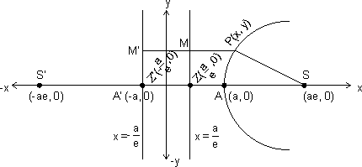
The standard equation of hyperbola is:
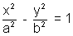
where b² = a²(e²-1)
Why ?
Let s be the focus & ZM the directix of the hyperbola. Draw SZ ZM & Divided SZ internally & externally in the ratio e:1 (e>1) & let A & A' be their internal & external points of division, then
SA = eAZ & ...................(1)
SA'= eA'Z ........................(2)
Points A & A' will lie on the hyperbola. Let AA' = ZA & take C, the mid point of AA' of AA' as origin.
i.e. CA = CA' = a
Let P be any point on the hyperbola.
Then adding (1)& (2) we get
SA + SA' = e( AZ + A'Z)
(CS - CA) + (CS + CA') = eAA'
2cs + CA' - CA = e(za)
But CA' = CA, Hence
2CS = 2ae
CS = ae
Thus focus S is ( ae, 0)
Now subtrating (1) from (2) use get
SA'- SA = C(A'Z - AZ)
AA' = e[( CA' + CZ) - (CA - CZ)]
AA' = e[2CZ + CA' - CA]
But CA'= CA, then
2a = e(2cz)
CZ = a/e
Thus directrix is x = a/e
Now draw PM MZ
We know by the definaton of hyperbola, that
= SP = ePM
= (sp)² = e²(pm)²
= 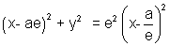
= (x - ae)² + y² = (ex - a)²
= x² + a²e² - 2aex + y² = e²x² + a² - 2aex
= x²(e² - 1) - y ² = a²(e² - 1)
= 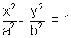
=
where b² = a²(e² - 1)
ILLUSTRATION : 1 .
Find the equation of hyperbola whose foci are (2, 4) & (10, 4) & eccentricity is 2.
Ans: We know that the center of hyperbola is the mid point of two foci i.e. coordinates of centers are (6, 4). We also know that the distance between two foci is 2ae.
i.e (10 - 2)² + (4 - 4)² = (zae)²
2ac = 8
4a = 8
a = 2
b² = a ²(e² -1), Hence
a = 2
b² = 4(4 - 1) = 12
The required equation of hyperbola is
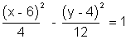
SOME TERM RELATED TO HYPERBOLA
(i) CENTER : This is the mid point of line joining the two foci. In standard form C is (0,0).
(ii) ECCENTRICITY : This is the ratio of the distances of any point on hyperbola from focus to the directrix. Here we have
& b² = a²(e² - 1)
e = 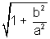
(iii) FOCI: Foci consists of two points on the transvers axis of hyperbola whose mid point is the center of hyperbola. Coordinates: (Iae, 0)
(iv) DIRECTRICES : There are the two lines perpendicula to the transverse axis on oppsite sieds of centre. In standard form directrices are
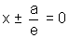
(v) AXES : In standard form points A(a,0) & A'(-a, 0) are called the vertices of hyperbola line AA' is called transverse axis & perpendicular to this is called conjugate axis.
(vi) DOUBLE ORDINATES : This is the length of the chord of hyperbola with end points as a, a', which is perpendicular to the transverse axis.
If the abscissa of Q is h then
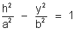
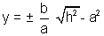
Hence coordinates of Q & Q' are 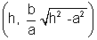& 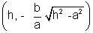.
(vii) LATUS RECTUM: The double coordinates which pass through foci are called Latus rectums. The abscissa of Latus rectums are Iae. Hence the coordinates are 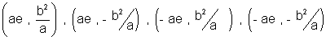, & the length of Lotus rectum is 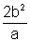.
(viii) FOCAL CHORD : A chord of hyperbola that passes through focus is called the focal chord of hyperbola.
(ix) PARAMETRIC EQUATION OF HYPERBOLA: The parametric equations of given hyperbola
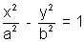 are
x = a sec
y = b tan
why ?
Let be the hyperbola with centre C & transverse axis AA', Then the circle drawm with centre C & segment AA' as diameter is called auxiliary circle. Equation is:
x² + y ² = a²
Let P be any point on hyperbola & Q on circle Draw PN perpendicular to axis & NQ be the tangent ot circle, then join CQ.
Let eccentric angle of P
since Q = (a cos , a sin )
x = CN = a sec
But P(x, y) lies on hyperbola, then
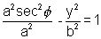
y = b tan
Hence the parametric equations of hyperbola are x= sec , y = tan
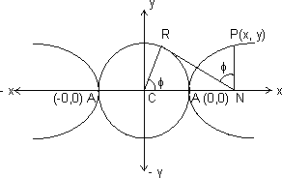
ILLUSTRATION : 2. Find the centre, foci, vertices, eccentricity, length, of axes, Latus Rectum & directrices of the hyperbola 3x² - 2y² + 12x + 4y + 4 =0
Ans: 3x² - 2y² + 12x + 4y + 4
= 3(x² + 4x + 4 - 4) - 2 (y ² - 2y + 1 - 1) + 4
3(x+2)² - 12 - 2(y - 1)² + 2 + 4 = 0
3(x + 2)² - 2 (y - 1)² = 6
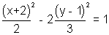
Centre = (- 2, 1)
Here a² = 2
b² = 3
Hence 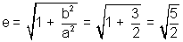
foci = (± ae, 0) = 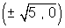
vertics = (± ae,0) = 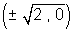
eceentricity =
length of axex = 2a & 2b
=
Latus Rectum = 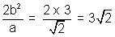
Directrices =
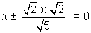
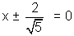

FOCAL DISTANCES OF A POINT:
Another Defination of hyperbola is that the difference of focal distances of any point on hyperbola is constant & equal to the length of transverse axis of the hyperbola.
Why ?
Let the hyperbola be
We know that
Distance from focus = (Distance from Directrix)
Hence Distance of point P(x₁, y₂) from S,(ae,0) is
SP = ePM = e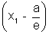 = ex₁ - a
Similarly S'P = e(PM') = e = ex₁ + a
Hence S'P - SP = 2a
= Transverse axis
Hence Hyperbola is the Locus of a point which moves in a plane such that the difference of its distances from two fixed points i.e. foci is constant.
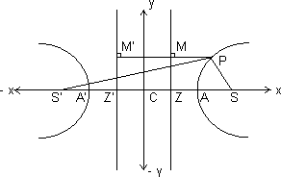
POINT AND HYPERBOLA
The point (x₁, y₂) lies outside, on ,or inside the hyperbola accordingly as 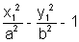< , = or > 0
Why ?
Let P = (x₁, y₂) & Q = (x₁ y₁)
Draw QL perpendicular to x axis then
QL > PL
y₁ > y₂
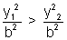
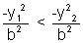
Adding on both sides
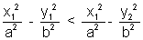
But 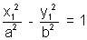
Hence 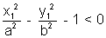
When point lies outside. Similarly we can prove that when point lies on of inside the hyperbola Then 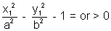
LINE AND A HYPERBOLA
The line y = mx + c will cut the hyperbola in two points, one point or will not cut accordingly as c² >, = or < a²m² - b²
Why ?
Let the line be y = mx + c ............................................. (1)
& the hyperbola .......................................... (2)
Eliminating y form (1) & (2) we get
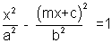
x²(a²m² - b²) + 2mca²x + a²(b² + c²) = 0
This is a quadratic is x, hence
Discriminant = b² - 4ac
= 4m²c²a⁴ - 4(a²m² - b²)(a²)(b² + c²)
= c² + b² - a²m²
Line will cut in two points if D > 0
c² + b² - a²m² > 0 c² >a²m² - b²
Line will touch the parabola if D = 0
i.e. c² + b² - a²m² = 0 c² = a²m² - b²
Line will not be touch or be touch a chord of parabola
if D < 0 i.e. c² + b² - a²m² < 0
c² < a²m² - b²
ILLUSTRATION : 3.
For what values of K will the line y = 3x + K be a chord to the hyperbola 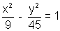
Ans: For this hyperbola we have
a² = 9 & b² = 45
From the equation of given line
m = 3 & c = k
Hence we know that for a line to be a chord to hyperbola c² > a²m² - b²
i.e. K² > 9 x 9 - 45
K² > 36
K² - 36 > 0
(K - 6)(K + 6) > 0
Hence
EQUATIONS OF TANGENT
(a) POINT FORM:
The equation of tangent to the hyperbola at (x ₁y₁) is 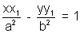
i.e. T = 0 where T = 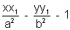
Why ?
The equation of hyperbola is:
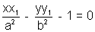
Differentiating w.r.t.x. we get
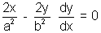
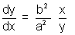
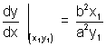
Equation of tangent when it passes through (x₁y₁) is
(y - y₁) = 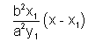
a²y₁y - a²y₁² = b²x₁x - b²x₁²
Dividing whole equation by a²b² we get
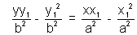
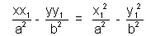
But 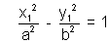as (x₁, y₁) lies on hyperbola
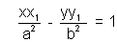is the requurired equation
(b) PARAMETRIC FORM:
The equation of tangent to hyperbola at
(a sec, b tan) is
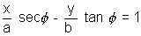
Why ?
We have to paranetric equations of hyperbola as
x = a sec & y = b tan
Differentiating both equations we get dx = a sec tan d & dy = b sec² d
Hence dividing these equations we get,
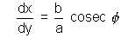
Hence the equations of tangent is (y - b tan) = 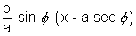
ay sincos - ab sin² = cosbx - ab
say sin cos - bx cos = - ab cos²
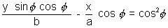
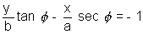
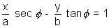 is required equation.
SLOPE FORM:
The equations of tangent to the hyperbola of slope m is y = mx ± & coordinates of points of contact are
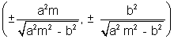
Why ?
Let the line with slope m be
y = mx + c, tangent to
Eliminating y from these two equations we get
(a²m² - b²)x² + 2 mca²x + a²(c² + b²) = 0
This is a quadratic equations in x hence for only one solution D should be zero.
D = b² - 4ac = 4m²c²a⁴ - 4(a²m² - b²(a²b² + c²) = 0
c² = a²m² - b²
c =
Hence the equation of tangent is:
y = mx .................................. (1)
Now, we also know that the equation of tangent at (x₁, y₁) is
......................................... (2)
Comparing (1) & (2) as they are the same equation we get
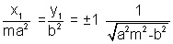
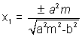&
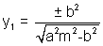
Hence the coordinates of point of contact are 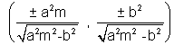.

ILLUSTRATION : 4.
Find the equations of the tangent to the hyperbola 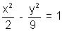which is perpendicular to the line 3y + x =1
Let the slope of line be m then 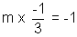
m = 3
& a² = 2 & b² = 9
Hence equations of tangents are:
i.e. y = 3x +
& y = 3x -
equations are
y = 3x + 3
& y = 3x - 3
EQUATIONS OF NORMAL
(a) POINT FORM:
Equations of normal to the hyperbola at (x₁,y₁) is 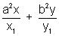= a² + b²
Why ?
The equations of hyperbola is
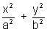- 1 = 0
Differentiating w.r.t.x we get
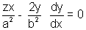
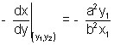
Hence the equation of normal is
(y - y₁) = 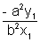(x - x₁)
b²x₁y - b²x₁y₁ = - a²y₁x + a²x₁y₁
Dividing whole equation by x₁y₁
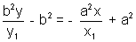
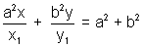is the required equation
(b) PARAMETRIC FORM:
The equation of normal at (a sec, tan) to the hyperbola is
xa cos + by cot = a² + b²
Why ?
We know that the parametric equations of hyperbola are
x = a sec y = tan
Differentiating them we get
dx = a sec tand & dy = bsec²d
Dividing them we get
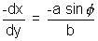
Hence the equation of normal is
(y - b tan) = 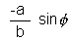(x - a sec)
by - b² tan = - ax sin + a²t an
ax sin + by = (a² + b²)tan
Dividing whole equation by tan we get
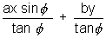= a² + b²
as cos + by cot = a² + b² is required equation.
(c) SLOPE FORM:
The equations of the mormals of slope m to the hyperbola are given by
Why ?
We know that the equation of normal at (x₁, y₁) is = a² + b²
since m is the slope, then
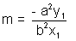
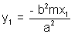
& (x₁, y₁) lies on 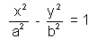
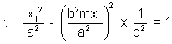
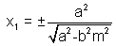
y₁ = ±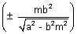
Hence the equation of normal in term of slope is
y - = m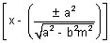
y = mx ± 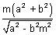is the required equation of normal in slope form.
Illustration : 5.
Find the equation of normal to 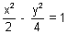at the poimt whose eccentric angle is .
Ans: We know the equation of normal in terms of eccentric angle is
ax cos + by cot = a² + b²
Here = 45⁰, a = , b = 2
ax cos45⁰ + by cot45² = a² + b²
.x. + 2.y.1 = 2 + 4
x + 2y = 6 is the required equation.
EQUATION OF A CHORD BISECTED AT A GIVEN POINT:
The equation of a chord of hyperbola , bisected at (x₁, y₁) is T = S₁ where T = 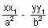- 1 & S₁ = 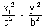- 1
i.e. =
Why ?
Let QR be the chord whose mid point is P. Since Q & R lies on hyperbola.
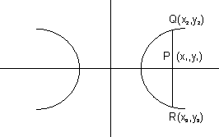
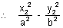= 1 .............................. (i) & also
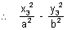= 1 .............................. (ii)
Subtracting (ii) from (i) we get
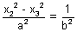(y₂² - y₃²)
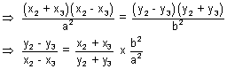
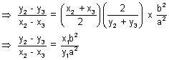
Hence slope of chord joining Q & R is
The equation of chord QR is
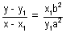
yy₁a² - y₁²a² = xx₁b² - x₁²b²
Dividing whole equation by a²b² we get
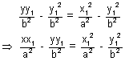
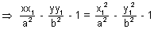
T = S₁
is the required equation of chord with given mid point.
PAIR OF TANGENTS
The combined equation of pair of tangents drawn from a point (x₁, y₁) to the hyperbola is 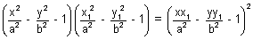
i.e. SS₁ = T²
where S = ; S₁ = 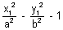; T = 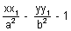
Why ?
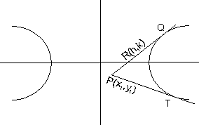
Let R(h, k) be any point on pair of tangents PQ or PT from any external point P(x₁, y₁) to the hyperbola .
Equation of PR is
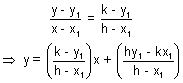
But this line is a tangent to the hyperbola so it must be of the form.
y = mx ±
Here c = 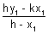 & m = 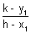
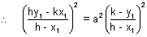- b²
(hy₁ - kx₁)² = a²(k - y₁)² - b²(h - x₁)²
Hence locus of (h, k) is
(xy₁ - yx₁)² = a²(y - y₁)² - b²(x - x₁)²
(xy₁ -- yx₁)² = - (b²x² - a²y²) - (b²x₁² - a²y₁²) - 2(a²yy₁ - b²xx₁)
Dividing whole equation by a²b² we get
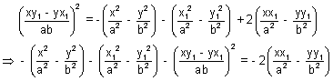
Adding 1 + 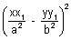on both sides we get
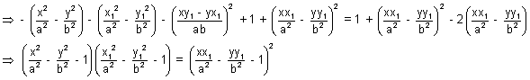
i.e. SS₁ = T²

Illustration : 6.
Find the equation of pair of tangents drawm from a point P(1, 1) to the hyperbola 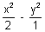= 1.
Ans: Here a² = 2 b² = 1
S = - 1
S₁ = 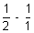- 1 = -
T = 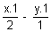- 1 = - y - 1
Hence equation is SS₁ = T²
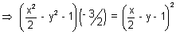
- 3(x² - 2y² - 2) = (x - 2y - 2)²
4x² - 2y² - 4x + 8y - 4xy - 2 = 0
2x² - y² - 2x + 4y - 2xy - 1 = 0 is the equation of pair of tangents.
CHORD OF CONTACT:
If the tangent from a point P(x', y') to the hyperbola touch the equation of chord of contact QR is
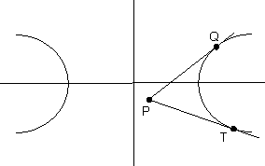
Why ?
Let Q = (x₁, y₁) & R = (x₂, y₂)
We know that PQ & Pr are tangents, hence equation of PQ is
= 1 ......................................... (i)
equation of PR is
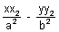= 1 ........................................ (ii)
Since both (i) & (ii) passes through P(x', y')
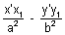= 1 ........................................ (iii)
& 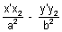 = 1 ........................................ (iv)
By looking carefully at (iii) & (iv) we can say that (x₁, y₁) & (x₂, y₂) lies on
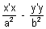= 1 i.e. T = 0.
POLE AND POLAR:
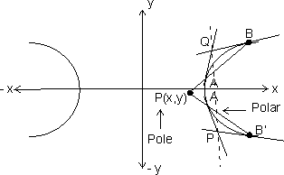
Let P(x₁, y₁) be any point inside or outside the hyperbola the if any straight line drawn through P intersects the hyperbola at A & B. Then the locus of points of intersection of tangents to the hyperbola at A & B is called the polar of the given point P with respect to hyperbola & the point P is called the pole of the polar.
Why ?
Let P be (x₁, y₁) & hyperbola be . If tangents to the hyperbola at A & B meets at Q(h, k), then AB is the chord ofcontact with respect to Q(h,k).
Equation of AB is
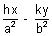
But P(x₁, y₁) lies on it, hence
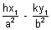= 1
Hence locus of Q(h, k) is
This is required equation of polar with (x₁, y₁) as its pole.
Illustration : 7.
Find the pole of given line y = mx + c with respect to hyperbola .
Ans: Let the pole of line be (, ) then the polar with respect to hyperbola is
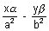= 1
But we have given the polar to be
y = mx + c
Hence by comparing the coefficients we get
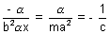
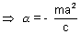 & 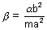
Hence pole is 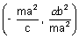
DEAMETER:
The locus of the middle points of any set of parallel chords of a hyperbola is called a diameter & the point where diameter intersects the hyperbola iscalled the vertex of diameter & equation of diameter is y = .
Why ?
Let y = mx + c be a set of parallel chords with c as a variable.
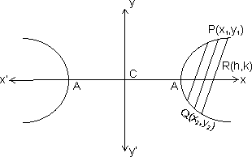
By solving y = mx + c , we get
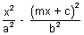= 1
(a²m² - b²)x² + 2mca²x + a²(b² + c²) = 0
This equation has roots x₁ & x₂
x₁ + x₂ = 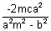......................................... (i)
But (h, k) is the middle point of QR then,
h = 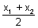.................................................. (ii)
From (i) & (ii)
h = 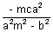
c = 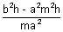
We also know that (h, k) lieson y = mx + c
k = mh + c
k = mh + 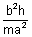- mh
k = .
CONJUGATE DIAMETERS
Two diameters are said to beconjugate when each bisects all chords parallel to the others.
Why ?
Let one set of parallell chords be
y = mx + c .............................................. (i)
then its diameter is y = 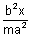
Let other set of parallel chords be
y = m₁x + c
then its diameter is y = 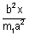........................ (ii)
But slope of equation (i) & (ii) are same, therefore
= m
mm₁ =
Therefore product of the slopes of two conjugate diameter is .
Illustration : 8.
Find the condition for the lines 2Ax² + 2Hxy + By² = 0 to be conjugate diameter of 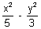= 1.
Ans: Let the slope of lines whose equation is 2Ax² + 2Hxy + By² = 0 be m₁ & m₂ then we know that
m₁m₂ = ........................................... (i)
We also know that if m₁ & m₂ are the slopes of two conjugate diameters then
m₁m₂ = ........................................... (ii)
Hence by (i) & (ii)
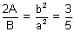
10A = 3B is the required condition.
DIRECTOR CIRCLE:
The locus of the point of intersection of the tangent to the hyperbola , which are perpendicular to each other is called director circle & the equation of director is
x² + y² = a² - b² (a > b )
Why ?
The equation of tangent to hyperbola with slope m is
y = mx + ................................... (i)
& the perpendicular tangent with slope - is
y = - x + 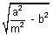................................... (ii)
x + my = 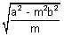.................................... (iii)
Squaring & adding equations (i) & (iii) we get
(y - mx)² + (x + my)² = a²m² - b² + a² - b²m²
(1 + m²)(x² + y²) = (1 + m²)(a² - b²)
(1 + m²)[x² + y² - (a² - b²)] = 0
As 1 + m² 0, therefore
x² + y² = a² - b² is the equation of director circle of hyperbola.
Illustration : 9.
Find the radius of the director circle of the hyperbola 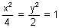.
Ans: We know the equation of director circle of is
x² + y² = a² - b²
Here a² = 4 & b² = 2
Therefore x² + y² = 4 - 2 = 2
x² + y² = ()² = r²
Here r = , Hence the radiusof director circle is units.
ASYMPTOTES
An asymptote of a hyperbola or any curve is a straight line which touches the curve at infinity at two points. The equation of asymptotes is y = ±
Why ?
Let y = mx + c be an asymptote to
Hence solving bot we get
(a²m² - b²)x² + 2a²mcx + a²(b² + c²) = 0
Now thishas two solutions for x & the asymptote touches the hyperbola at therefore both the roots must be . By looking at the above equation the only way that can be a solution is to be zero. Therefore
a²m² - b² = 0 & 2a²mc = 0
m = ± & c = 0
Substituting m & c in y = mx + c
We get
y = ± x is the required equation of asymptotes.
Illustration : 10.
Find the angle between asymptotes of hyperbola 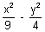= 1.
Ans: THe equation of asymptotes is
y = ± = ±
Now we have to find angle between two lines
y = & y = -
If m₁ & m₂ are slopes than angle between them is
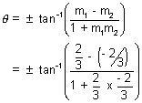
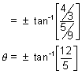
Hence the acute angle between the asymptotes is 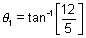
& the obstuse angle is
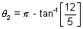

CONJUGATE HYPERBOLA
The hyperbola whose transverse & conjugate axes are respectively the conjugate & transverse axes of the standard hyperbolais called the conjugate hyperbola of the standard given hyperbola. The conjugate hyperbola of is 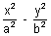= - 1.
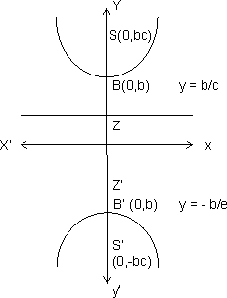
SOME RESULTS OF CONJUGATE HYPERBOLA
(a) Length of Transverse axis = 2b
(b) Length of conjugate axis = 2a
(c) Foci = (0, ±be)
(d) Equation of Directrices = y = ± b/e
(e) Eccentricity = e = 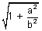
(f) Length of Latus Rectum =
(g) Parametric co-ordinates = (a tan, b sec)
(h) Equation of transverse axis = x = 0
(i) Equation of conjugate axis = y = 0
Illustration : 11.
Find the length of transverse axis, conjugate axis eccentricity, coordinates of foci, vertices, length of latus rectum & equation of directrices of the hyperbola 9x² - 4y² = - 36.
Ans: The hyperbola is
9x² - 4y² = - 36
= - 1 i.e of the form
= - 1 where a = 2 & b = 3
Length of transverse axis = 2b = 6units
Length of conjugation axis = 2a = 4 units
Eccentricity = 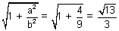
Vertices = (0, ± b) = (0, ± 3)
Length of Latus Rectum = 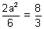units
Equation of directrices = y = ± b/e
= y = ± 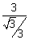
= y = ±
= y = ± 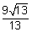
RECTANGULAR HYPERBOLA DEFINITION
(1) A hyperbola whose asymptotes include aright angle is called a rectangular Hyperbola. THe general form of the equation of hyperbola is x² - y² = a² = b².
Why ?
The asysmptotes of a hyperbola is
y = ±
If these are at right angles than
m₁m₂ = - 1
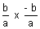= - 1
b² = a²
Hence the equation of ractangular hyperbola is 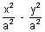= 1
x² - y² = a²
(2) If the length of transverse & conjugate axes of any hyperbola are equal, it is called as rectangular hyperbola.
Why ?
IF a = b, then = 1 become
= 1 x² - y² = a²
RECTANGULAR HYPERBOLA (xy = c²)
The equation of Rectangular Hyperbola is x² - y² = a²
i.e. (x + y)(x - y) = a²
We know that x + y =0 & x - y = 0 are at 45⁰ & 135⁰ to the x axis. Now if we can rotate the axes through = - 45⁰ without changing the origin.
So, we can replace (x, y) by
(x cos - y sin, x sin + y cos) i.e.
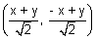
The equation x² - y² = a² becomes
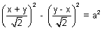
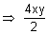= a²
xy =
Let = c² = any positive constant
Therefore xy = c² is the another form of Rectangular hyperbola.
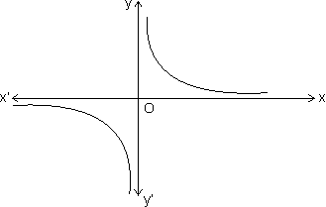
RESULTS OF RECTANGULAR HYPERBOLA
(a) The parametric coordinates are x = ct & y = c/t.
(b) Equation of chord joining t₁ & t₂ is
x + yt₁t₂ = c(t₁ + t₂)
(c) Equation of tangent at t is + yt = x.
(d) Point of intersection of tangents at 't₁' & 't₂' is 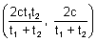.
(e) Equation of normal at 't' is
xt³ - yt - ct⁴ + c = 0.
(f) Points of intersection of normals at 't₁' & 't₂' is
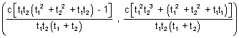
Illustration : 12.
Find the eccentricity of Rectangular Hyperbola.
Ans: For the hyperbola = 1; c =
Therefore for = 1 we have b = a
Hence eccentricity of Rectangular hyperbola is .
Easy
1. For what value of k does 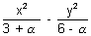= 1 represents a hyperbola ?
Ans: We know that the standard form of hyperbola can be = 1 or = - 1.
CASE - I
= 1
As a² & b² are +ve quantities greater than zero simultaneously, therefore
3 + > 0 & 6 - > 0
> - 3 & < 6
Hence common solution is
- 3 < < 6
CASE II
= - 1 or 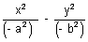= 1
Here also - a² & - b² are -ve quantities.
Therefore
3 + < 0 & also 6 - < 0
< - 3 & > 6
There is no common solution.
Hence the only solution is
- 3 < < 6 or (- 3, 6)
Q.2. Find the value of c if the ellipse 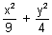= 1 & x² - y² = c² cut at right angles ?
Ans: The curves cut at right angle means that the tangents at the point of intersection of two curves are at right angles. If m₁ is the slope of the tangent to ellipse & m₂ is the slope of the tangent to hyperbola, then
m₁ = 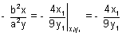.......................... (i)
m₂ = 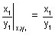....................................... (ii)
using (i) & (ii)
m₁m₂ = - 1
= 1
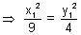
But 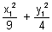= 1 as (x₁y₁) lies on hyperbola
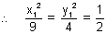
x₁² = 9/2 ................................................ (iii)
y₁² = 4/2 ............................................... (iv)
Bur x₁² - y₁² = c² .......................................... (v)
Using (iii) & (iv) in (v) we get
c² = 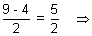c = ±
Q.3. Prove that if normal to the hyperbola xy = c² at any point t₁ meets the curve again at t₂, then, t₁³t₂ = - 1.
Ans: Equation of normal at point t₁ is
yt₁ - xt₁³ = c - ct₁⁴
Now if this normal again meets at 't₂', then (ct₂, ) must satisfy the normal
t₁ - ct₂t₁³ = c - ct₁⁴
ct₁³[t₂ - t₁] = [t₁ - t₂]
ct₁³t₂[t₂ - t₁] + c(t₂ - t₁) = 0
c(t₂ - t₁)(t₁³ + 1) = 0
As t₂ t₁ & c > 0
t₁³t₂ + 1 = 0
t₁³t₂ = - 1
Q.4. If (a sec, b tan) & (a sec, b tan) are the end points of a focal chord of the hyperbola = 1, then prove that tan tan = 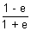.
Ans: The equation of chord joining the points (a sec, b tan) & (a sec, b tan) is
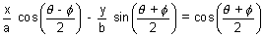
It passes through focus (ae, 0), then
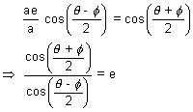
Applying componendo & dividendo we get
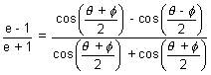
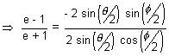
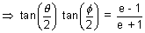
Q.5. Find the locus of poles of normal chords of the rectyangular hyperbola xy = c².
Ans: Equation of normal at any t is
xt³ - yt = c(t⁴ - 1) ........................................ (i)
Lert its ple be P(x₁, y₁) then the equation of polar is
xy₁ + x₁y = 2c²..................................................... (ii)
Comparing the coefficients of equations (i) & (ii) as they represent same equation
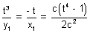
t² = - .............................................................. (iii)
& 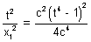 .......................................................... (iv)
From (iii) & (iv)
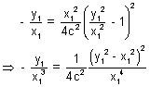
(x₁² - y₁²)² = - 4c²x₁y₁
Hence locus of (x₁, y₁) is
(x - y)² + 4c²xy = 0
Q.6. Find the co-ordinates of the foci & equation of the directrices of rectangular hyperbola xy = c² ?
Ans: When the hyperbola x² - y² = a² converts into xy = c² by rotation by - 45⁰ then a² = 2c².
So, for = 1
Coordinates of foci are (± ae, 0) = (± a, 0)
Also directrices are x = ± = ± 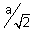
Now we replace 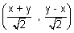for (x, y) & 2c² = a².
Foci = 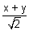= ± a & 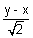= 0
x = y = ± 2a
So Foci are (± 2a, ± 2a)
i.e. (± c, ± c)
Also directrices are
= ±
x + y = ± a
x + y = ± c ( a² = 2c²)
are the directrices of the rectangular hyperbola.

Q.7. If the tangent at P of the hyperbola xy = c² meets the asymptotes ate L & M & C is the centre of hyperbola. Prove that PL = PM = CP.
Ans:
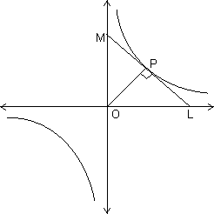
Let P(ct, ) be any point, then equation of tangent at P is
x + t²y = 2ct
It meets the asymptotes i.e. x = 0 & y = 0 at L, M respectively.
L = (2ct, 0)
& M = (0, )
Clearly mid point of LM is 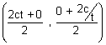
= (ct, ) = P
Therefore PL = PM = ................................................... (i)
& CP = 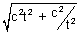
But ML = 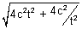
ML = 2
ML = 2CP
CP = ................................................. (ii)
By (i) & (ii)
PL = PM = CP
Q.8. Find the equation of hyperbola whose asymptotes are 2x + y + 2 = 0 & x + y + 3 = 0 & which passes through (0, 1), also find the equation of conjugate Hyperbola.
Ans: We know that the combined equation of asymptotes & hyperbola differ by a constant.
The combined equation of assymptotes is
(2x + y + 2)(x + y + 3) = 0
2x² + y² + 3xy + 8x + 5y + 6 = 0
Then let the equation of hyperbola be
2x² + y² + 3xy + 8x + 5y + 6 + = 0
As it passes through (0, 1) we get
0 + 1 + 0 + 0 + 5 + 6 + = 0
= - 12
Hence the equation of hyperbola is
2x² + y² + 3xy + 8x + 5y - 6 = 0
We also know that
The equation of conjugate hyperbola = 2(combined equation of assymptotes) - (equation of hyperbola)
equation of conjugate hyperbola is
2(2x² + y² + 3xy + 8x + 5y + 6) - (2x² + y² + 3xy + 8x + 5y - 6)
equation of conjugate hyperbola is
2x² + y² + 3xy + 8x + 5y + 18 = 0
Q.9. If the polars of (x₁, y₁) & (x₂, y₂) with respect to hyperbola = 1 are at right angles, then show that 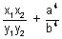= 0.
Ans: Equation of polar of (x₁, y₁) & (x₂, y₂) with respect to hyperbola = 1 are
= 1 & = 1
Therefore the slopes are
& 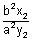
Since the polars are at right angles
x = - 1
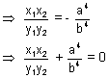
Q.10. Prove that product of perpendiculars from any point on the hyperbola = 1 to its asymptotes is 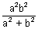.
Ans: The asymptotes are
y = & y = -
Let the point be P (x₁, y₁)
Perpendicular distance from y = is
L₁ = 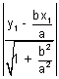
Perpendicular distance from y = - is
L₂ = 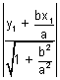
L₁L₂ = 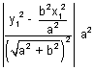
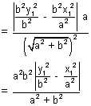
But = 1 (x₁, y₁ lies on hyperbola)
L₁L₂ = 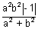
L₁L₂ =
MEDIUM
Q.1. Show that the locus of the centre of circle which touches two given circles externally is a hyperbola.
Ans: Let C₁, C₂ be the centres of the two given circles & p & q be their radii. Let be the radius of the circle touching them externally & c be its centre, then,
CC₁ = p + r
CC₂ = q +
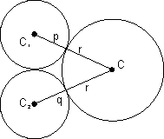
We can see that
CC₁ - CC₂ = p - q = constant
Here we observe that the difference of distances of the centre from two fixed points is constant. Hence it satisfies the property of hyperbola the locus of centre is a hyperbola.
Q.12. Find the locus of mid points mid of the chord of x² + y² = 16 which are tangets to the hyperbola 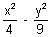= 1.
Ans: The equation of chord of circle with (h, k) as mid point is
T = S₁
i.e. hx + ky - 16 =h² + k² - 16
hx + ky = h² + k² .................................................... (i)
If (i) is the tangent to hyperbola therefore it must be of the form
sec - tan = 1
here a = 2 b = 3
sec - tan = 1 .................................................. (ii)
Equating coefficients of (i) & (ii)
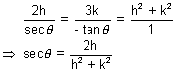
& tan = - 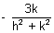
Using sec² - tan² = 1 we get
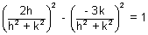
4h² - 9k² = (h² + k²)²
Locus of (h, k) is (x² + y²)² = 4x² - 9y²
Q.13. A circle with cintre (3, 2) & of variable radius cuts the rectangular hyperbola x² - y² = 9a² at the points A, B, C, D. Find the locus of centroid of triangle ABC ?
Ans: The equation of circle is
(x - 3)² + (y - 3)² = ² .................................. (i)
& hyperbola is
x² - y² = 9a² ..................................................... (ii)
Eliminating y from (i) & (ii) we get
4x⁴ - 24x³ + .............................. = 0
It is a equation of power four, having roots as x₁, x₂, x₃, x₄.
Let (h, k) be the centroid of PQR
Then,
h = 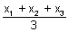
& k = 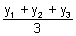
We have x₁ + x₂ + x₃ + x₄ = 6 ................................. (iii)
& similarly y₁ + y₂ + y₃ + y₄ = 6

Therefore using (iii) & (iv) we get
h = 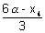
& k = 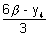
But (x₄, y₄) lies on hyperbola
x₄² - y₄² = 9a²
9(h - 2)² - 9(k - 2)² = 9a²
(h - 2)² - (k - 2)² = a²
Hence the Locus of (h, k) is
(x - 2)² - (y - 2)² = a²
Q.14. A normal to the hyperbola = 1 meets the axes in M & N & lines MP & NP are drawn perpendicular to the axes meeting at P. Find the Locus of P.
Ans:
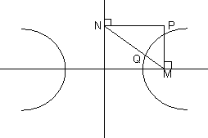
Equation of normal at Q is ax cos + by cot = a² + b². The normal meets the x-axis at M
M = 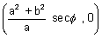
& N = 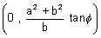
Equating of line MP is
x = 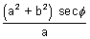.................................... (i)
& equating of line NP is
y = 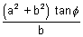.................................... (ii)
From (i) & (ii)
sec² - tan² = 1
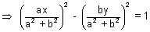
a²x² - b²y² = (a² + b²)²
is the required Locus of P.
Q.15. A point P moves such that the tangents from it to the hyperbola 4x² - 9y² = 36 are mutually perpendicular. Find the Locus of P.
Ans: We can write the combined equation of both thetangents. Let P = (,
Then, SS₁ = T²
S< = 4x² - 9y² - 36
T = 4x - 9y - 36
S₁ = 4² - 9² - 36
Using SS₁ = T²
(4x² - 9y² - 36)(4² - 9² - 36) = (4x - 9y - 36)²
This is an equation of pair of lines, if these are perpendicular
then the coefficient of x² + coefficient of y² = 0
Coefficient of x²
= - 144 - 36² ............................... (i)
Coefficient of y²
= 324 - 36² ................................. (ii)
by (i) & (ii)
- 36² - 36² = - 180
² + ² = 5
Therefore the Locus of (, ) is x² + y² = 5
Which is the equation of director circle. Hence we can say that the Locus of point of intersection of two perpendicular tangents is the director circle.
HARD
Q.16. The normals at three points P, Q, R on a rectangular hyperbola intersects at a point T on the curve. Prove that the centre of hyperbola is the centroid of triangle PQR.
Ans: Equation of normal at any point (ct, ) on xy = c² is
xt³ - yt - ct⁴ + c = 0
It will pass through T. So, ht³ - kt - ct⁴ + c = 0 .......................... (i)
Let T = (h, k) & k = ........................................................ (ii)
Curve P is the parameter
By equations (i) & (ii) we get
cqt³ - t - ct⁴ + c = 0
qt³ - - t⁴ + 1 = 0
q²t³ - t - qt⁴ + q = 0
q(qt³ + 1) - t(qt³ + 1) = 0
(q - t)(qt³ + 1) = 0
but q t
qt³ + 1 = 0 ............................................. (iii)
This is a cubic equation in t representing the points P, Q, R where normals are drawn.
Let the roots be t₁, t₂, t₃ such that
P = (ct₁, q = (ct₂, ) R = (ct₃, )
From equation (iii) we get
t₁ + t₂ + t₃ = 0 ........................................ (iv)
& t₁t₂ + t₂t₃ + t₁t₃ = 0 ................................. (v)
Now the centroid of Triangle PQR is
x = c(t₁ + t₂ + t₃)
= c(0) (From equation (iv)
= 0
y = + +
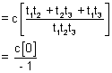
= 0 (From equation (v))
Hence the centroid of PQR is (0, 0) which is the centre of the given hyperbola.
Dumb Question: Initially we have considered the point 't' & Later use considered t₁, t₂, t₃ so this t is t₁ or t₂ or t₃ ?
Ans: Initially we have written that consider any point 't' which can be either t₁ or t₂ or t₃. If it is t₁, other two are t₂, t₃ & if its is t₂, other two are t₁, t₃ & so on. These three point forms a symmet4ry, therefore t is general, either t₁, t₂ or t₃.
Q.17. The chord of contact of the tangents through P to the hyperbola = 1 subtends a right angle at the centre. Prove that the Locus of P is the ellipse ?
Ans: Let the point P be (h, k), then the equation of chord of contact is
= 1
Now we know that the equations of line passing through origin & the points of intersection of chord of contact with hyperbola is obtained by homogenizing the hyoerbola.
Therefore
= 1
Can be written as
= (1)² = 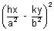
because = 1
= 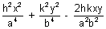
This is a homogeneous equation representing pair of staright lines, if these subtend a right angle at the centre than
Coefficient of x² + coefficient of y² = 0
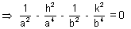
Multiplying by a⁴b⁴ we get
a²b² - h²b⁴ - a⁴b² - k²a⁴ = 0
b⁴h² + a⁴k² = a²b²(b² - a²)
Hence the Locus of (h, k) is
b²x² + a²y² = a²b²(b² - a²)
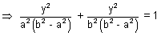
Hence the Locus is an ellipse.
Dumb Question: Why we have homogenised the hyperbola ?
Ans: Let us consider a general curve
ax² + 2hxy + by² + 2gx + 2fy + c = 0
& any general line lx + my + n = 0
By making the curve homogeneous means
By usig given line make the curve homogeneous of degree 2.
Consider lx + my + n = 0 , then
l = 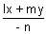
Now consider curve
ax² + 2hxy + by² +2gx.1 + 2fy.1 +c.(1)² = 0
ax² + 2hxy + by² +2gx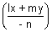 + 2fy + c² = 0
Hence this is a curve passing through origin & also homogeneous & because it is obtained by the help of curve & the line it represents the pair ofstaright lines passing through origin & points of intersection of line with the curve.
i.e. of OA & OB.
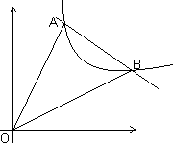
KEY WORDS
Focus.
Vertex.
Directrix.
Eccentricity.
Latus Rectum.
Absicca.
Ordinate.
Centre.
Axes.
Double Ordinate.
Focal Chord.
Parametric Equation.
Eccentric Angle.
Focal Distance.
Conjugate Hyperbola.
Tangent.
Normal.
Slope.
Pair of Tangents.
Chord of Cantact.
Pole.
Polar.
Diameter.
Conjugate Diameter.
Director Circle.
Asymtotes.
Rectangular Hyperbola.
Locus.
Transverse Axis.
Conjugate Axis.

